CN Lab 02

**Task 1:**

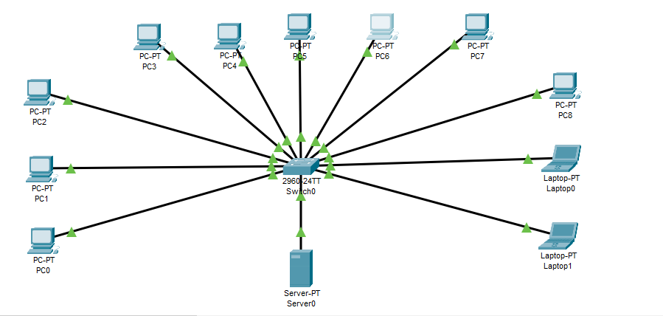

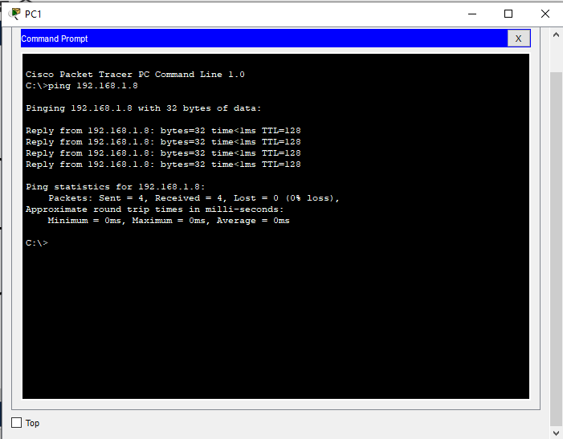

**Task 2:**

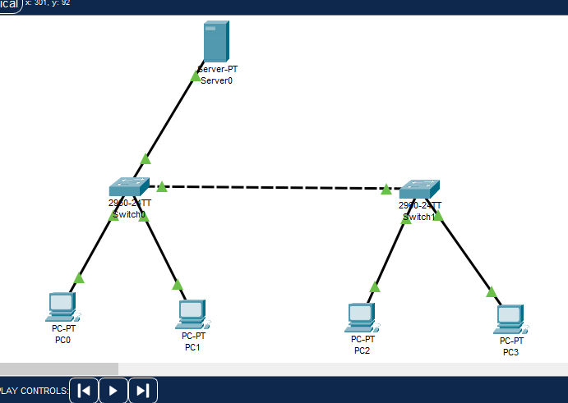

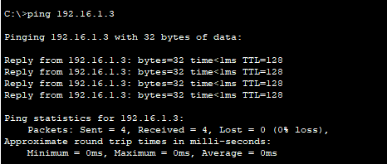

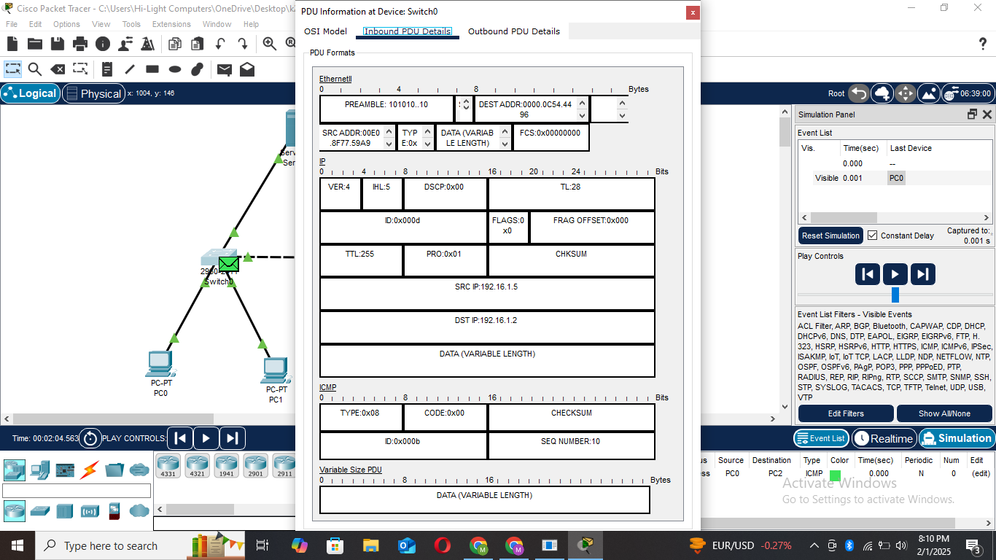

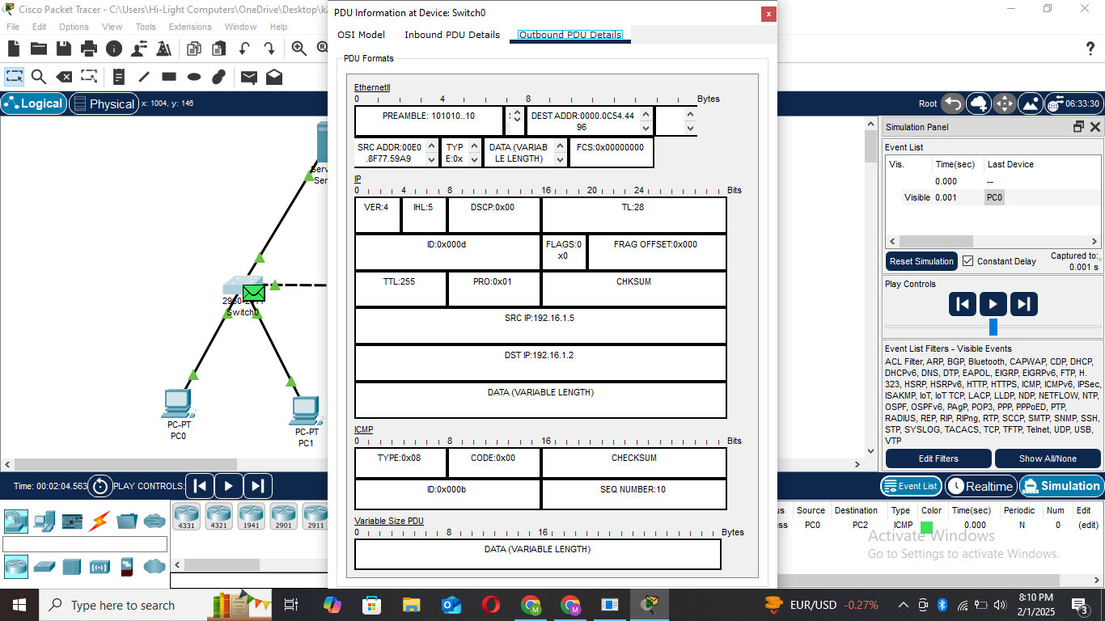

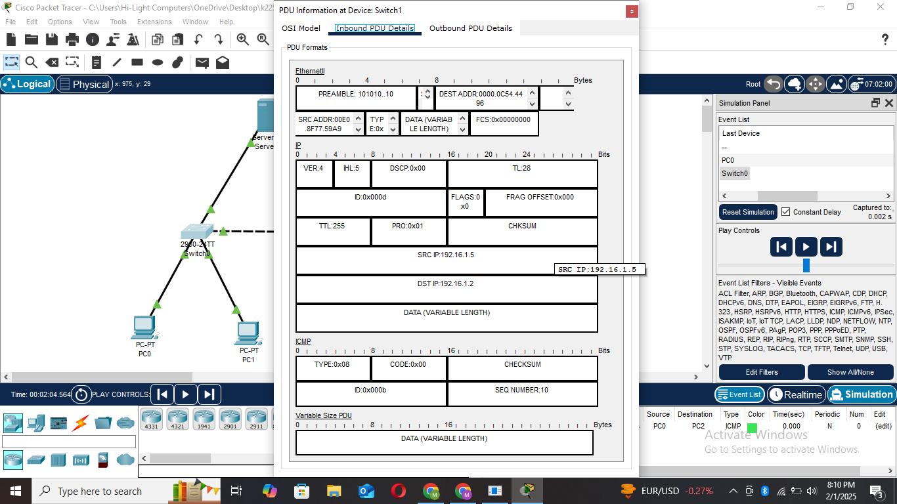

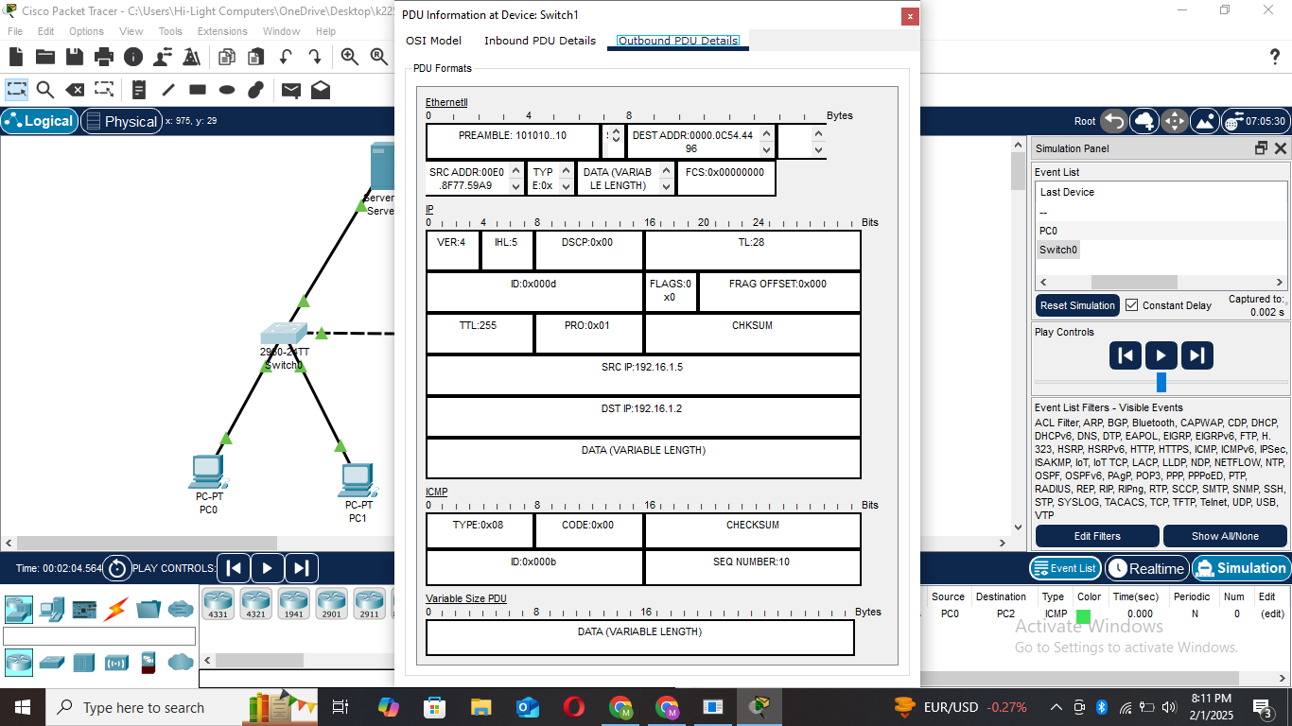

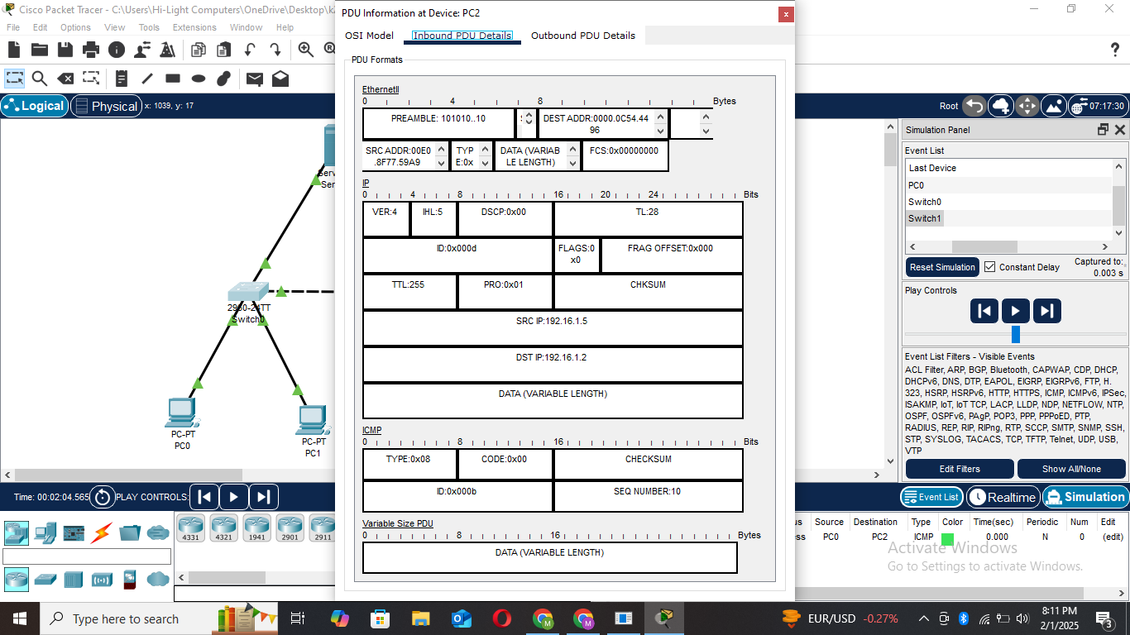

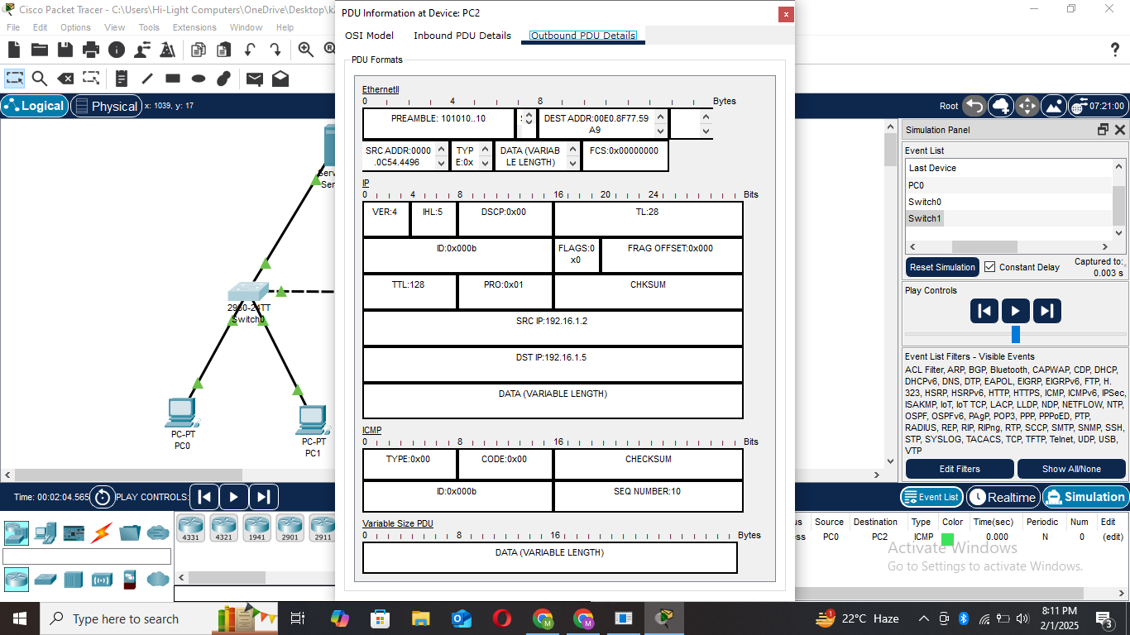

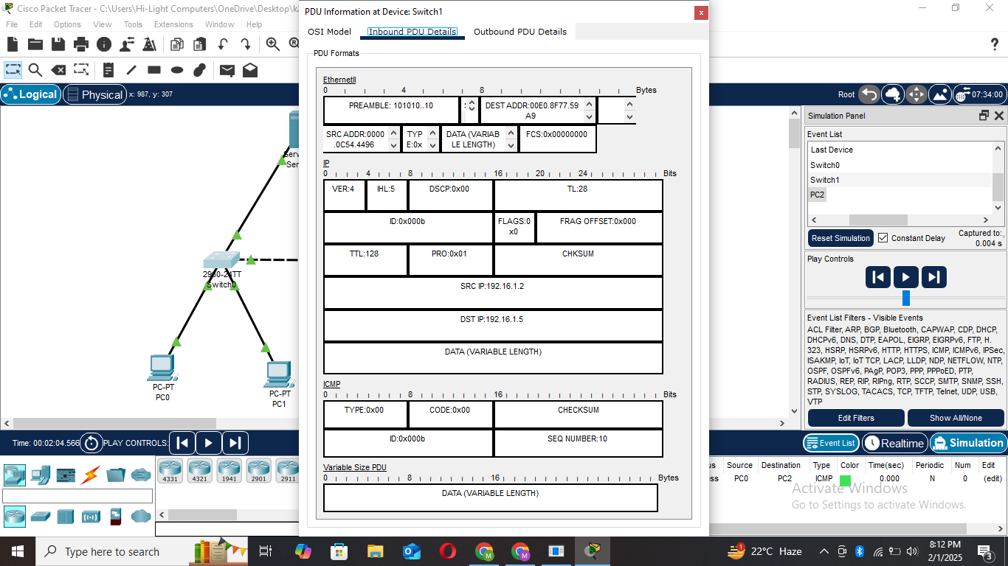

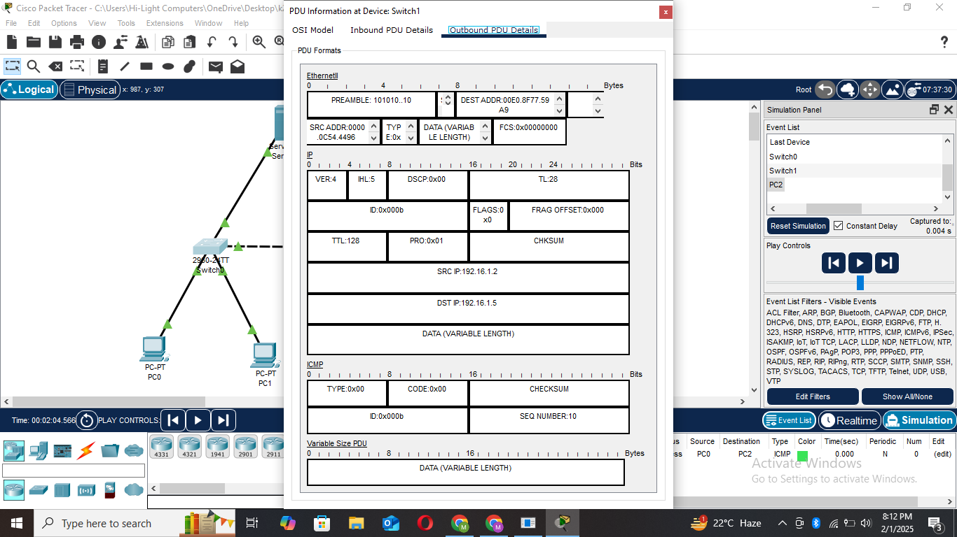

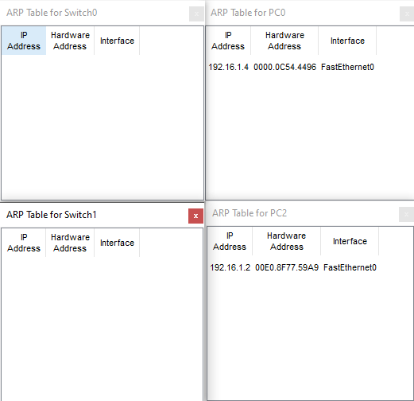

**Task 3:**

1. Switch transfers message from one end device to the designated end device, while Hub transfers message from one end device to all other end devices.

Logical mode displays logical diagram of the network and connections between multiple devices.

Physical mode displays a map, which shows us buildings and other physical factors.

1. **Segment 1:** Straight cable

**Segment 2:** Crossover cable

**Segment 3:** Crossover cable

**Task 4:**

1. Step 1: Message sent from PC1 to Hub0.

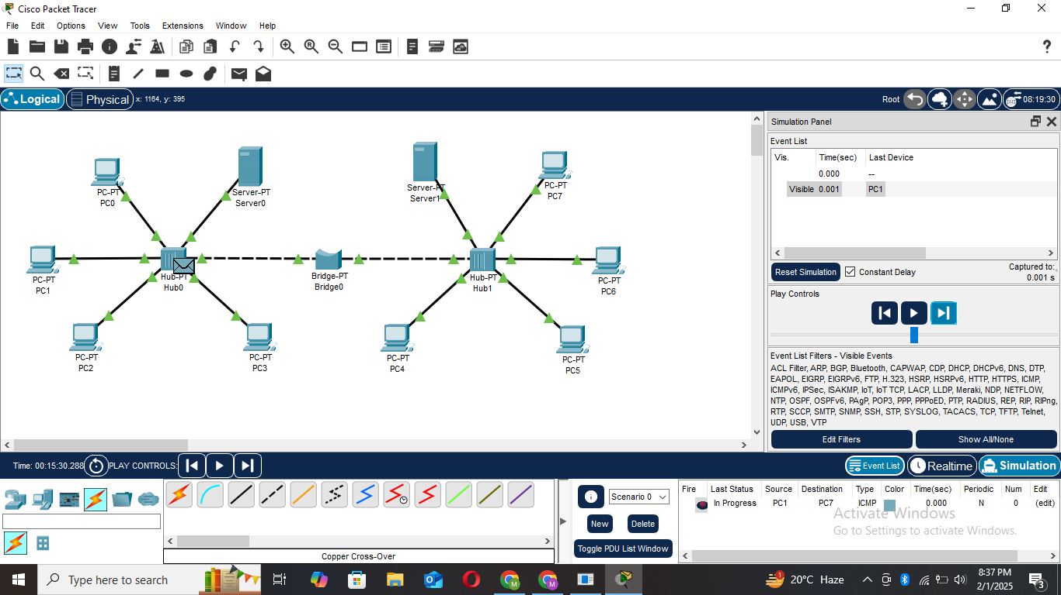

1. Step 2: Message sent from Hub0 to Bridge0, PC0, PC2, PC3 and Server0.

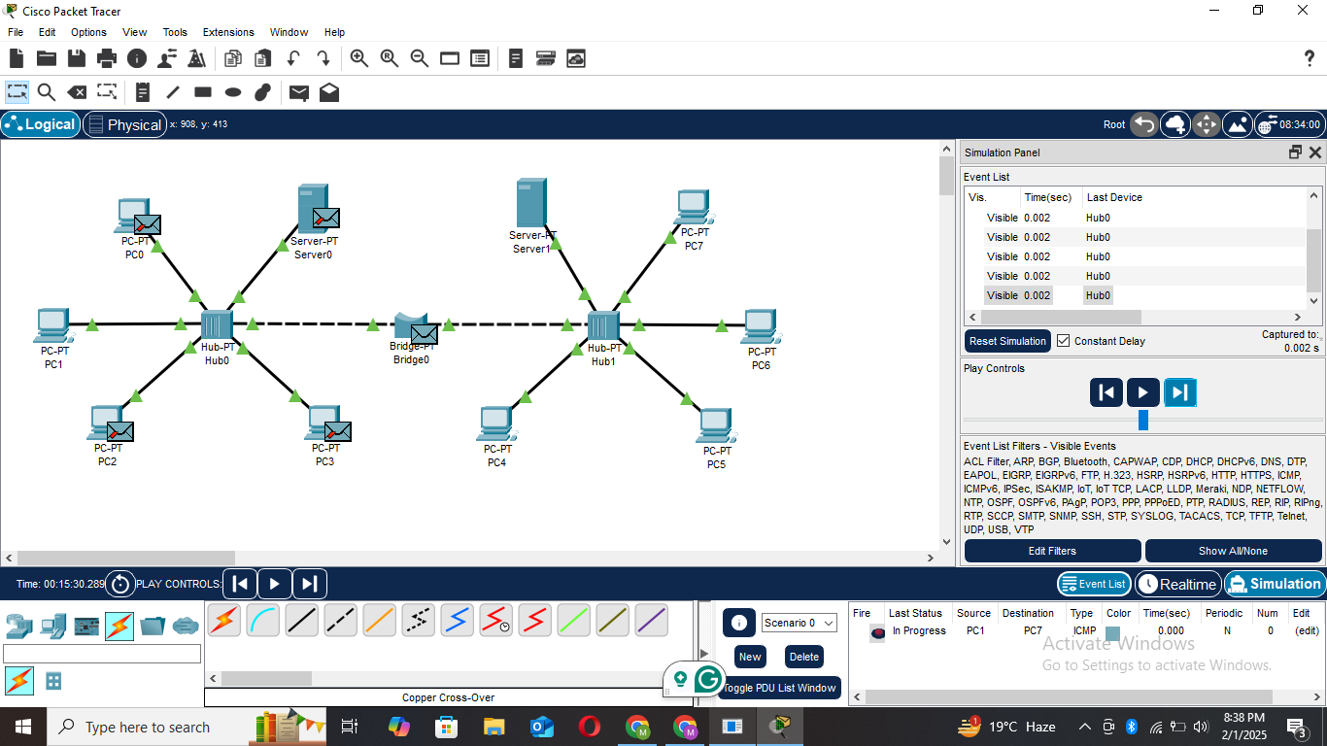

1. Step 3: Message sent from Bridge0 to Hub1.

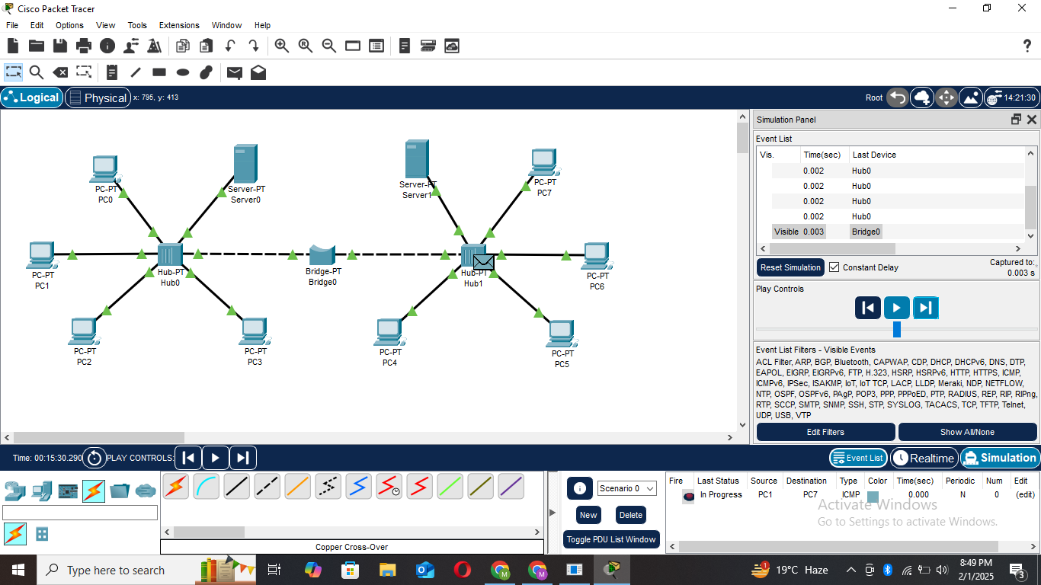

1. Step 4: Message sent from Hub1 to Server1, PC4, PC5, PC6, and PC7 (intended destination).

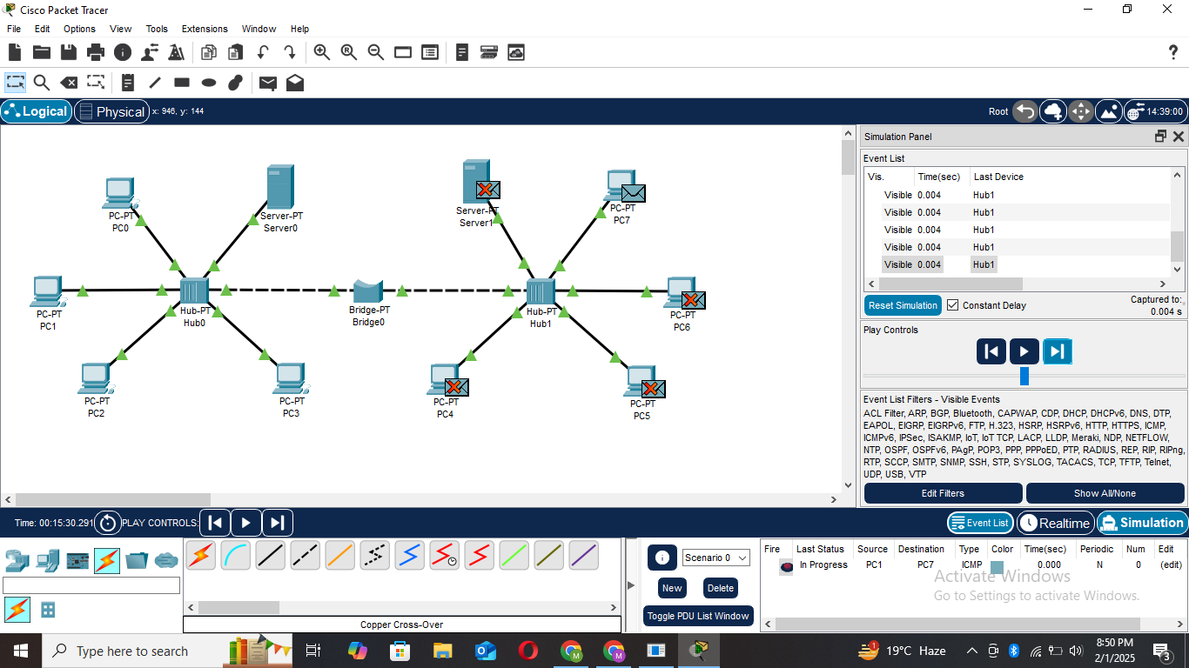

**Task 5:**

